Comhaltas Ceoltóirí Éireann  Sean Doherty Branch Perth WA  Fleadh Cheoil PERTH WA  9:00am for 9:30am start - Saturday 12th April 2025  Vic Park RSL 1 Fred Bell Parade EAST VICTORIA PARK  Foirm Iontrála / Entry Form | 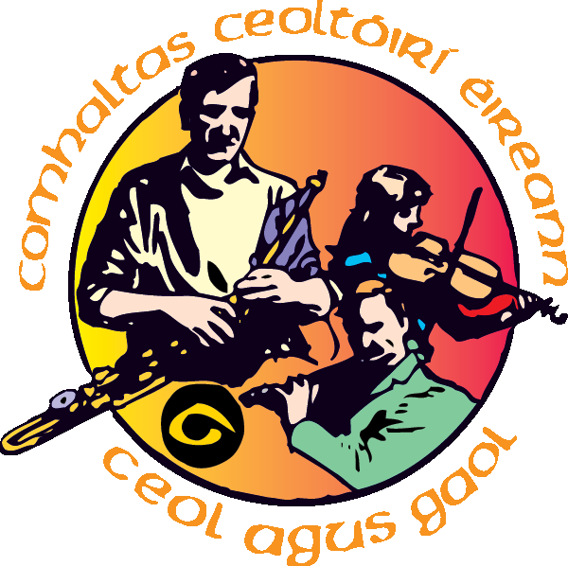
Ainm/Name:___________________________________________________________
Seoladh/Address:_______________________________________________________
Dáta Breithe/Date of Birth (U-18): _________ Aois Grúpa/Age Group: __________
Ríomhphost/Email: _____________________ Uimhir Guthán/Tel No.: ____________
Craobh Comhaltais/Comhaltas Branch: Sean Doherty Branch Perth WA
Iontrála/Entries:
Uimhir Comórtas: Instrument | Ainm Comórtas:  Age Group (please refer to RULES) >> please tick 
 | (Under 12) | 12 – 15 | 15 - 18 | Over 18
1 Fidil – Fiddle
2 Bosca Ceoil – Button Accordion
3 Feadóg Mhór – Flute
4 Feadóg – Whistle
5 Cairdín Pianó – Piano Accordion
6 Consairtín – Concertina
7 Píb Uilleann – Uilleann Pipes
8 Cruit – Irish Harp
9 Orgán Béil – Mouth Organ
10 Bainseó – Banjo
11 Maindilín – Mandolin
14 Rogha Gléas – Miscellaneous (specify):___________________
16 Bodhrán
23 Ceol Beirte – Duets * (all names on this one form)
24 Ceol Trír – Trios # (all names on this one form)
31 / 33 Singing** (Ladies) (specify): Sean Nós / English
32 / 34 Singing** (Men) (specify): Sean Nós / English
** please state you two Irish traditional song choices:_song 1)_______________________song 2) ________________________
* Ceol Beirte – Duets: (Please name your Duet partner) partner ______________________
# Ceol Trír – Trios: (Please name your Trio partners) partner 1)___________________partner 2)___________________
Tick box to confirm you are a current CCÉ Member and Entrance Fee of $10.00 per entrant has been PAID.
Cheques can be made payable to: Comhaltas Perth Inc
In providing the above information, competitors agree to their name, age group and branch appearing on any fleadh programmes, which will be distributed to Comhaltas committee, judges and organising staff and also for inclusion on adjudication sheets. In signing this form, it is also understood that photographs taken at Fleadh Cheoil PERTH together with name, age group and branch may be used in local media, the PERTH Comhaltas website and social media.

Síniú/Signed: |  | Date:
 | Competitor's Signature OR Parent / Guardian Signature (if u18)
All competitors must REGISTER AT THE VENUE at least 30 minutes before their competition. In an effort to have competitions run to time, please notify Brendan if you decide to withdraw from a competition. Go raibh maith agat
Send form to branch Secretary by Sunday 6th April 2025 to >> David Charlesworth perthcomhaltas@gmail.com
Payment can made either by:
- Cash or cheque to Dave Hill (Comhaltas Treasurer), Brendan Doherty or David Charlesworth at the Vic Park RSL Tuesday nights; OR
- Bank Transfer* (details below)* Please state your full name on Bank Transfer to assist us to verify your payment
Bendigo Bank
BSB Number: 633-000
Account Number: 154 379 267

