Comhaltas Ceoltóirí Éireann  Sean Doherty Branch Perth WA  Fleadh Cheoil PERTH WA  Saturday 12th April 2025  9:00am for 9:30am start  Victoria Park RSL 1 Fred Bell Parade  EAST VICTORIA PARK | 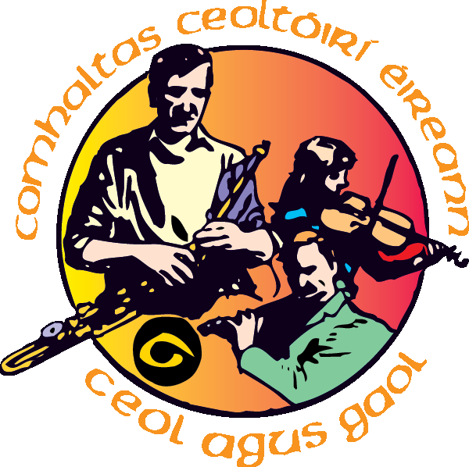
Music Competition Rules
Please send your entrance form to the Branch Secretary by Sunday 6th April 2025
>> David Charlesworth perthcomhaltas@gmail.com

Trio and Duet entrance to be completed on one form stating all names in the group.

The draft program of the competition Program including names of competitors, instrument and scheduled time slot will be sent by email to all competitors by 8th April 2025. Scheduled time slots are approximate.

General
- Entrance Fee of $10.00 per entrant
- Maximum of two entrance categories per entrant only.
- Only Traditional Irish Music will be permitted.
- Reading from music notation is not permitted.
- Recorded music is not permitted.
- Electronic or amplified instruments and equipment not permitted.
- All competitors in duet and trio must play melody instruments.
Duet must be with two different instruments
Trio must have at least one different instrument. (eg: can’t be three fiddles)
- Bodhran competitor must perform to melodies played live by an instrument player.
Bodhran competitor must organise their own live melody player.
- Medals may be awarded for First, Second and Third, but not necessarily in every section.
- Adjudicator decision is final.
- Winners will be announced as soon as possible after the competition.

AGE CATEGORIES:
(A) Under 12: a person whose 12th or earlier birthday occurs on any date in 2025.
(B) 12-15: a person whose 13th, 14th or 15th birthday occurs on any date in 2025.
(C) 15-18: a person whose 16th, 17th or 18th birthday occurs on any date in 2025.
(D) Over 18: a person whose 19th or greater birthday occurs on any date in 2025.

Arrive well before your time slot, tune up and get ready
All competitors must REGISTER AT THE VENUE at least 30 minutes before their competition. In an effort to have competitions run to time, please notify your branch secretary if you decide to withdraw from a competition.

Please tune up before entering the competition room, be seated in the waiting area at least 10 minutes before your time slot.

You will be called up to play.
Wait for the adjudicator to ask you what you are playing or singing before you start each piece.
Play your chosen tunes in your own preferred order (eg you may prefer to play your easier tune first).
Play each tune twice through only.
Wait for the adjudicator’s instruction before leaving the stage.

- Traditional Irish Tune selection

Two (2) different tunes must be played with a pause between each tune. Each tune must be of a different rhythm
(ie you can’t play two reels or two jigs etc)

Original Composition – if you are entering the original composition section please use Section 14 Miscellaneous on the entrance form. Your original composition must conform to one of the rhythm types listed below unless it is a slow air.

Choose one tune from:
- Reel (includes single or double)
- Jig (includes single, double, slip 9/8 or slide 12/8)

Choose a second tune (ie a different rhythm to your first selection) from:
- Reel (includes single or double)
- Jig (includes single, double, slip 9/8 or slide 12/8)
- Hornpipe
- Polka
- March
- Slide
- Set dance
- Mazurka
- Planxty
- Fling
- Barn Dance
- Schottische
- Clan March
- Highlands
- Germans

- Traditional Irish Song selection

Two (2) different songs must be sung with a pause between each song. One song must be slow and one lively.

Both songs must be genuine Irish Traditional Songs.

